**-GROUP 7**

-Group Members :

1.Tatiana Tan

2.Arun Sharma

-Date: 07/14/2024

-Assignment: Assignment: Milestone #1

-GitHub link: <https://github.com/SharmaArun017/CSD310.git>

- Selected Case Study

**(Bacchus Winery Case Study) -** After reviewing the case studies, As we decided to focus on the Bacchus Winery Case Study. I believe it offers the best opportunity to develop a comprehensive solution involving inventory management, online ordering, and employee tracking, aligning well with our team's skills and interests.

“As most of the work was done by making sure everything was team decision and combined at last with work divided as done in discussion post Threads”

= Tatiana Tan

Case study: Bacchus Winery Case Study

Here are some business rules that I came up with.

1. Bacchus Winery grows and sells four types of wine: Merlot, Cabernet, Chablis, and Chardonnay.

2. Each type of wine has a unique identifier.

3. Suppliers provide bottles, corks, labels, boxes, vats, and tubing.

4. Suppliers deliver monthly; delivery times are tracked.

5. Distributors can order wines online and track shipments.

6. Employee hours are tracked quarterly.

7. The system tracks the inventory of supplies.

8. The system tracks which distributor carries which wine.

9. Inventory must be ordered on a monthly basis or as needed.

10. Order confirmation must be sent automatically to the distributor upon order placement.

11.Overtime must be pre-approved by a supervisor.

12. Any discrepancies must be reported and corrected within 24 hours.

- Assumptions : (Same as team decision)

1. Each type of wine, supplier, distributor, order, and employee has a unique identifier (WineID, SupplierID, DistributorID, OrderID, EmployeeID).

2. Supplies are categorized into types such as bottles, corks, labels, boxes, vats, and tubing.

3. Deliveries are tracked monthly, and the system records both expected and actual delivery times.

4. Distributors can place orders and track shipments online, indicating the system supports an e-commerce functionality.

5. Employee working hours are tracked quarterly, with each employee associated with a specific department.

6. Each wine type has a specific price associated with it.

7. The system tracks the inventory of supplies, and each supply item is linked to a specific supplier.

8. Each distributor can carry multiple types of wine, and this relationship is tracked in the system.

- Entities and Relationships

Entities:

1. **Wine**
   * WineID (PK)
   * WineName
   * Type
   * Price
2. **Supplier**
   * SupplierID (PK)
   * SupplierName
   * ContactInfo
3. **Supply**
   * SupplyID (PK)
   * SupplyType
   * Quantity
   * SupplierID (FK)
4. **Distributor**
   * DistributorID (PK)
   * DistributorName
   * ContactInfo
5. **Order**
   * OrderID (PK)
   * OrderDate
   * DistributorID (FK)
6. **OrderDetails**
   * OrderDetailsID (PK)
   * OrderID (FK)
   * WineID (FK)
   * Quantity
7. **Employee**
   * EmployeeID (PK)
   * EmployeeName
   * Department
   * HoursWorked

* Simple Relationships
* One-to-Many:
* Supplier to Supply (One to Many)
* Distributor to Order (One to Many)
* Order to OrderDetails (One to Many)
* Wine to OrderDetails (One to Many)
* One-to-One:
* Employee to Department (for simplicity) (One to Many)

* Summary of Relationships
* Supplier - Supply:
* One supplier can provide many supplies (One-to-Many).
* Distributor - Order:
* One distributor can place many orders (One-to-Many).
* Order - OrderDetails:
* One order can have many order details (One-to-Many).
* Wine - OrderDetails:
* One wine can appear in many order details (One-to-Many).
* Employee:
* For simplicity, each employee is linked to a single department (One-to-One).
* ERD :

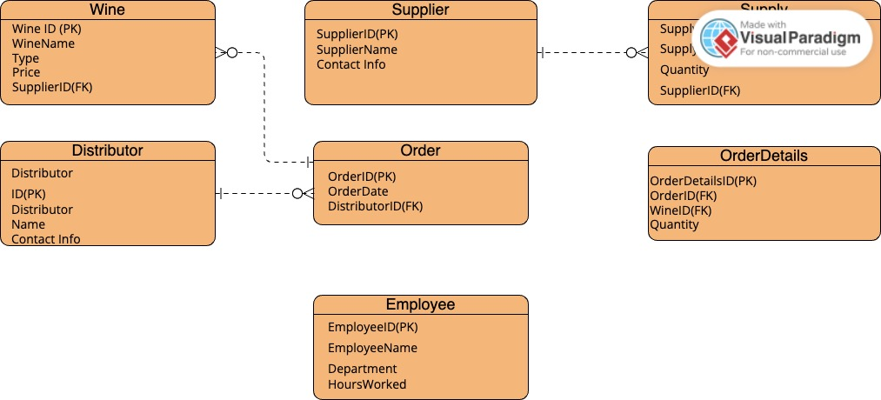

= Arun Sharma

Case study: Bacchus Winery Case Study

- Business Rules: (Some additional) as you already posted the business rules

* Bacchus Winery has a hierarchical employee structure with roles such as finance, marketing, production, and distribution.
* Each type of wine is produced in distinct batches, with each batch having a unique batch number.
* Supplier contracts are renewed annually and include clauses for on-time delivery.
* Inventory levels for supplies are monitored weekly, with automatic reorder triggers.
* Distributors must have a verified account to place orders online.
* Employee performance reviews are conducted semi-annually.
* The system supports bulk order discounts for distributors.
* The winery maintains a customer feedback loop for product improvement.
* Wine production data is tracked per batch for quality control.
* Financial reports are generated monthly to review expenses and revenue.

- Here are some additional business rules and assumptions I've thought of:

* Each wine type has a specific production cost and selling price.
* Each employee has a unique identifier and is assigned to specific roles such as winemaking, bottling, or sales.
* The system must track sales performance by employee and by wine type.
* Wine batches have a production date and an expiration date.
* Quality control checks are performed weekly and recorded in the system

- Assumptions : (Same as Team decision)

1. Each type of wine, supplier, distributor, order, and employee has a unique identifier (WineID, SupplierID, DistributorID, OrderID, EmployeeID).

2. Supplies are categorized into types such as bottles, corks, labels, boxes, vats, and tubing.

3. Deliveries are tracked monthly, and the system records both expected and actual delivery times.

4. Distributors can place orders and track shipments online, indicating the system supports an e-commerce functionality.

5. Employee working hours are tracked quarterly, with each employee associated with a specific department.

6. Each wine type has a specific price associated with it.

7. The system tracks the inventory of supplies, and each supply item is linked to a specific supplier.

8. Each distributor can carry multiple types of wine, and this relationship is tracked in the system.

### **Entities and Relationships**

#### **Entities:**

1. **Wine**
   * WineID (PK)
   * WineName
   * Type
   * Price
2. **Supplier**
   * SupplierID (PK)
   * SupplierName
   * ContactInfo
3. **Supply**
   * SupplyID (PK)
   * SupplyType
   * Quantity
   * SupplierID (FK)
4. **Distributor**
   * DistributorID (PK)
   * DistributorName
   * ContactInfo
5. **Order**
   * OrderID (PK)
   * OrderDate
   * DistributorID (FK)
6. **OrderDetails**
   * OrderDetailsID (PK)
   * OrderID (FK)
   * WineID (FK)
   * Quantity
7. **Employee**
   * EmployeeID (PK)
   * EmployeeName
   * Department
   * HoursWorked

### **Simple Relationships**

* **One-to-Many**:
  + Supplier to Supply (One to Many)
  + Distributor to Order (One to Many)
  + Order to OrderDetails (One to Many)
  + Wine to OrderDetails (One to Many)
* **One-to-One**:
  + Employee to Department (for simplicity) (One to Many)

### **Summary of Relationships**

* **Supplier - Supply**:
  + One supplier can provide many supplies (One-to-Many).
* **Distributor - Order**:
  + One distributor can place many orders (One-to-Many).
* **Order - OrderDetails**:
  + One order can have many order details (One-to-Many).
* **Wine - OrderDetails**:
  + One wine can appear in many order details (One-to-Many).
* **Employee**:
  + For simplicity, each employee is linked to a single department (One-to-One).

ERD:

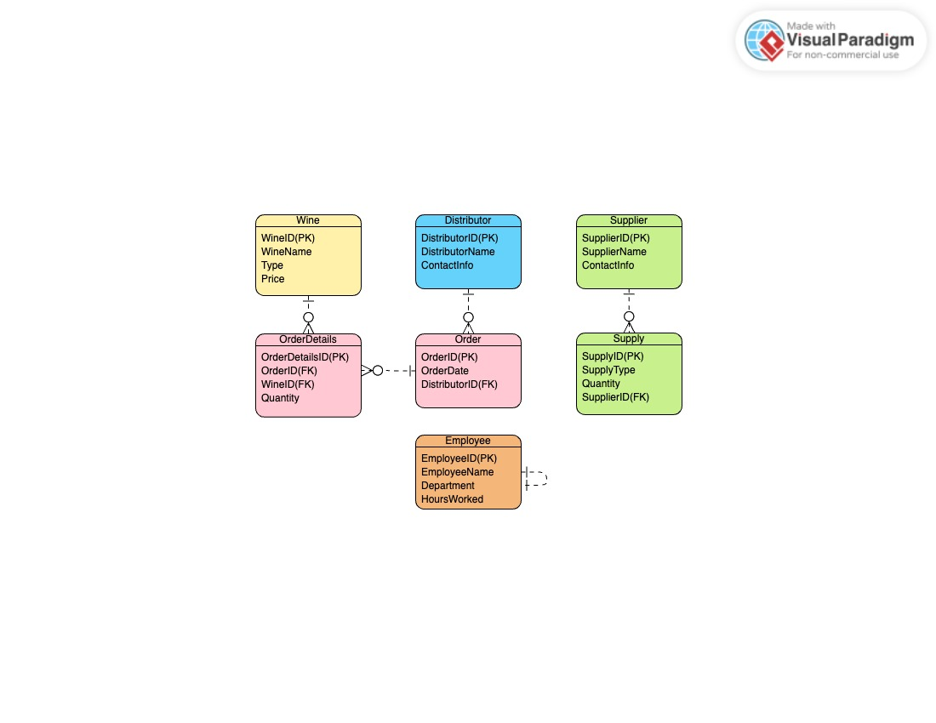

- But we also studied other case studies as well which are :

= Outland Adventures Case Study:-

Outland Adventures, founded by Blythe Timmerson and Jim Ford, caters to hiking and camping enthusiasts. They offer guided trips, equipment rentals, and sales. The business has seen significant growth, prompting Blythe and Jim to optimize operations. Key questions include analyzing equipment sales, identifying trends in trek bookings across Africa, Asia, and Southern Europe, and assessing the age of inventory items. The focus is on enhancing customer experience and operational efficiency by leveraging technology for better inventory and booking management.

= Willson Financial Case Study:-

Willson Financial, established by Jake and Ned Willson, provides financial management and advisory services in New Mexico. The firm caters to local ranchers, farmers, and retirees. With a growing client base, the company aims to evaluate its billing structure and client service efficiency. Key questions involve tracking new client additions, assessing average client assets, and identifying clients with frequent transactions. The goal is to ensure compliance with SEC regulations while optimizing financial management services for their clients.

== Decision:-

After reviewing the case studies, As we decided to focus on the Bacchus Winery Case Study. I believe it offers the best opportunity to develop a comprehensive solution involving inventory management, online ordering, and employee tracking, aligning well with our team's skills and interests.